Legend :
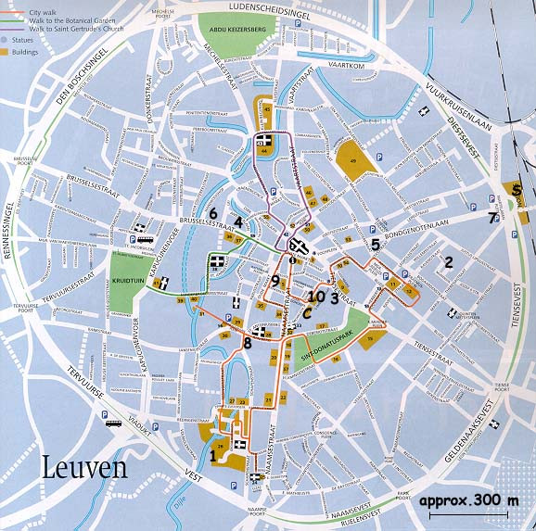
C : Maria-Theresia College, Congress-site
- : Begijnhof Congres Hotel
- : Hotel Binnenhof
- : Holiday Inn Garden Court
- : Hotel IBIS
- : Theater Hotel
- : Hotel Jackson’s
- : Hotel La Royale
- : Hotel New Damshire
- : Hotel Professor
- : Paus Adrianus VI-College
S : Railway Station

